Title: **Biodiversity conservation** **in an uncertain world**

Authors: Richard Schuster a,b,*, Rachel Buxtona, Jeffrey Hansona, Jeremy Pittmanc, Vivitskaia Tullochd, Frank La Sortee, Raquel Garciaf, Peter H. Verburgg, Amanda D. Rodewalde,h, Scott Wilsoni, Peter Arcesed, Hugh Possinghamj,k, Joseph R. Bennetta

Affiliations:

a Department of Biology, 1125 Colonel By Drive, Carleton University, Ottawa ON, K1S 5B6 Canada.

b Ecosystem Science and Management Program, 3333 University Way, University of Northern British Columbia, Prince George BC, V2N 4Z9 Canada.

cSchool of Planning, University of Waterloo, 200 University Ave W, Waterloo, ON, N2T 3G1, Canada

d Department of Forest and Conservation Sciences, 2424 Main Mall, University of British Columbia, Vancouver BC, V6T 1Z4 Canada.

e Cornell Lab of Ornithology, Cornell University, Ithaca, NY 14850, USA

f Centre for Invasion Biology, Dept of Botany and Zoology, Stellenbosch Univ, South Africa

g Environmental Geography Group, VU University Amsterdam, Amsterdam, The Netherlands

h Department of Natural Resources, Cornell University, Fernow Hall, #111, Ithaca, NY 14853, USA.

i Wildlife Research Division, Environment and Climate Change Canada, 1125 Colonel By Drive, Ottawa, Ontario, Canada, K1S 5B6

j Centre for Biodiversity and Conservation Science, University of Queensland, St Lucia, Queensland, Australia

k The Nature Conservancy, Arlington, Virginia

*Corresponding author: Department of Biology, 1125 Colonel By Drive, Carleton University, Ottawa ON, K1S 5B6 Canada. Email: [richard.schuster@glel.carleton.ca](mailto:richard.schuster@glel.carleton.ca), Phone: +1 250 631 8324, ORCID: 0000-0003-3191-7869

First paragraph

The dynamic nature of biological, economic, social, and political systems means that predicting outcomes of biodiversity conservation investments includes a high degree of uncertainty. Curbing biodiversity loss in a rapidly changing global environment is a complex race against time1,2. Investing in conservation projects that try to minimize uncertainty while maximizing biodiversity gains may be the most feasible mechanism to buffer high biodiversity against future change. Sources of uncertainty used here are political instability and corruption; weak governance; systemic crisis; the probability of project failure; climate change; and projected land use change. As climate change and land-cover change intensify in the coming decades, their interaction with socio-economic systems will influence the effectiveness of conservation tools such as protected areas and species management. Here we introduce a framework that can simultaneously incorporate a range of uncertainties into global biodiversity conservation planning. We highlight how incorporating these uncertainties can lead to more efficient and resilient conservation networks into the future. This represents an advancement over current practices, which identify areas crucial for conservation predominantly on the basis of measures of regional biodiversity or ecosystem services and do not incorporate multiple uncertainties at once. Our framework allows for robust conservation planning in an uncertain world.

**Main text**

As we lose biodiversity at an alarming rate2, protected areas are one of the best tools for conservation3; however, human-caused change results in high uncertainty of the performance of conservation land in the future. Effective decision-making must operate within the context of climate change, land use change, and complex interconnected socio-economic-ecological systems that interact and result in systemic environmental uncertainties primarily caused by the effects of human activities (Keys et al. 2019). Investing in conservation projects that try to minimize uncertainty while maximizing biodiversity gains may be the most feasible mechanism to buffer high biodiversity against future change.

The urgency of the biodiversity crisis and the many habitats and species at risk necessitate targeted action that maximizes the chances to protect essential components of biodiversity. While investments are high and hard to establish in current political environments such targeting needs the balance the urgency with maximizing the chance that the investments will deliver results. Likelihood for success is higher when protection measures are resilient against the impacts of land use change, climate effects and socio-political risks and uncertainties.

To prioritize conservation investments, generally the most cost-effective actions are weighed against the biodiversity benefits. However, both cost and benefit will look much different in the future, making investing without any consideration of future conditions risky. We consider the following sources of uncertainty: political instability and corruption; weak governance; systemic crisis; climate change; and projected land use change. We group these uncertainties in three board groups: i) socio-economic uncertainty; ii) climate uncertainty; iii) land use change uncertainty. As climate change and land-cover change intensify in the coming decades, their interaction with socio-economic systems will influence the effectiveness of conservation tools such as protected areas and species management.

Here, we introduce a framework that strives to minimize multiple sources of uncertainty, while maximizing biodiversity protection at the same time. We build on a classical problem formulation from the systematic conservation planning literature, which is the minimum set problem, where the goal is to minimize the cost of a solution, while reaching feature targets. We expand this approach to include multiple objectives in the problem formulation at the same time. Each objective represents a measure of uncertainty, we want to account for. We include i) socioeconomic uncertainty, ii) land use change uncertainty, iii) climate uncertainty, while maximizing the protection of 30930 vertebrate species globally.

We created 8 planning scenarios using vertebrate species data from the IUCN Red List of Threatened Species and incorporating different combinations of the 3 uncertainty metrics from above, as well as one baseline scenario, where we do not include a measure of uncertainty, representing the classical approach to solving these kinds of problems. As our scenarios were aimed at building on the current protected area portfolio globally, we forced protected areas to be part of the solution. For each scenario we set a 30% target for the vertebrate species, in line with developing guidelines from the IUCN (ref). We then compared the spatial representation of each scenario to each other at the global, as well as the country scale to investigate the effects that the inclusion of one to all three of our uncertainty metrics has on the outcome, with the idea that the scenarios incorporating all three uncertainty metrics would be the most resilient to future change in terms of protecting biodiversity.

Last, we compared scenario results across the 14 terrestrial biomes of the world to investigate biome scale effects accounting for our three uncertainty metrics would have. Exploring such constraints represents a critical step in conservation planning, given that human cultural history, values, and well-being can all affect conservation success and represent critical inputs into structured decisions about the most efficacious actions4–6. The framework we present here can be used for a wide variety of planning efforts, as it is highly flexible and can accommodate multiple objectives and features at the same time, introducing a way to allow for more resilient and effective conservation planning into the future.

**Results**

We found considerable variation in the spatial configuration of our scenario outcomes (Fig. 1). What was surprising and encouraging to us was that despite the spatial variation in outcomes, the total amount of land required to meet the 30% target for each species did not increase as much as we thought between the base scenario of not including any measure of uncertainty and any of the 7 variations of including uncertainty measures we tested (Table 1). The scenario that incorporated all three uncertainty metrics only required 0.59% more global area than the base scenario (28.2% vs 27.61%). This is encouraging because it means that we can account for these important measures of uncertainty to produce more effective and resilient conservation networks, while not needing to substantially increase the global area required to meet the 30% protection targets. In addition, we also found that all 8 scenarios investigated reached their goals without surpassing the 30% global area target that the Convention on Biological Diversity (CBD) is currently considering as post Aichi targets. This means that incorporating socio-economic, climate, and land use change uncertainties into protected area plans, can operate withing the CBD area goals. There is also considerable spatial overlap between scenarios, with 25.3 million km2 being selected for addition to the current protected area portfolio in at least 5 scenarios and 3 million km2 in all 8 scenarios.

These are encouraging results at a global level, but what about the country level? On average and across scenarios, the results are comparable with mean values ranging from 4% to 19% addition per country (Table 2). There is however a wide range of differences for individual countries, ranging from no additional protection recommended in a country to expanding the protection level 8.3 fold. If we take a relatively large sized country that is currently suffering from conflict, but also has low values of land use change and climate uncertainty (Figures S1-3) like Libya (1.8 million km2 land size) as an example, the scenario only including socio-economic uncertainty would lead to a selection of only 11% of the base line scenario (Table S1). If the focus is on land use change or climate only, the number of selected cells would increase to 126% and 130% respectively, compared to the baseline scenario. Including all three metrics at the same time leads to 121% selection compared to baseline. In contrast, a country of similar size to Libya but low levels of internal conflict would be Indonesia (also 1.8 million km2 land size). The values of Indonesia only vary by 6% across scenarios (98% to 104%), compared to the 119% percent variation present in Libya.

**Discussion**

We introduce a conservation planning framework that is able to incorporate a range of uncertainties related to socio-economic, land use change and climate that are likely impact the effectiveness of biodiversity protection into the future. Our results show that at the global level, accounting for these uncertainties represents an efficient way to safeguard the protected area portfolio against risk related to these uncertainties, while not requiring substantially more land to be placed under protection globally. For individual countries, results will look very different depending on their current socio-economic circumstances, climate realities and predicted land use changes. Individual countries don’t really have any control over what the climate will look like in the future, other than being part of a global movement to reduce greenhouse gas emissions. Where countries do have opportunities to influence out global priorities for biodiversity protection are the land use change and socio-economic levers.

>>>tough one: while conservation is often aimed at reducing the risks of land use change in practice it is very difficult to ensure full conservation in regions that are facing high land use change pressures (example is Indonesia where logging moratorium did not fully work given the high oil palm pressure (some references: https://www.sciencedirect.com/science/article/pii/S1389934118304623

**Main references**

1. Brondizio, E. S., Settele, J., Díaz, S. & Ngo, H. T. Global assessment report on biodiversity and ecosystem services of the Intergovernmental Science-Policy Platform on Biodiversity and Ecosystem Services. *IPBES Secretariat* (2019).

2. Rosenberg, K. V. *et al.* Decline of the North American avifauna. *Science* **366**, 120–124 (2019).

3. Watson, J. E. M., Dudley, N., Segan, D. B. & Hockings, M. The performance and potential of protected areas. *Nature* **515**, 67–73 (2014).

4. Barrett, C. B. & Arcese, P. Are integrated conservation-development projects (ICDPs) sustainable? On the conservation of large mammals in sub-Saharan Africa. *World development* **23**, 1073–1084 (1995).

5. Ban, N. C. *et al.* A social–ecological approach to conservation planning: embedding social considerations. *Frontiers in Ecology and the Environment* **11**, 194–202 (2013).

6. Schwartz, M. W. *et al.* Decision Support Frameworks and Tools for Conservation. *Conservation Letters* **11**, e12385 (2018).

7. Pouzols, F. M. *et al.* Global protected area expansion is compromised by projected land-use and parochialism. *Nature* **516**, 383–386 (2014).

8. Venter, O. *et al.* Targeting Global Protected Area Expansion for Imperiled Biodiversity. *PLOS Biology* **12**, e1001891 (2014).

9. Le Saout, S. *et al.* Protected areas and effective biodiversity conservation. *Science* **342**, 803–805 (2013).

10. Coetzer, K. L., Witkowski, E. T. & Erasmus, B. F. Reviewing B iosphere R eserves globally: effective conservation action or bureaucratic label? *Biological Reviews* **89**, 82–104 (2014).

11. Baynham-Herd, Z., Amano, T., Sutherland, W. J. & Donald, P. F. Governance explains variation in national responses to the biodiversity crisis. *Environmental Conservation* **45**, 407–418 (2018).

12. Garcia, R. A., Cabeza, M., Rahbek, C. & Araújo, M. B. Multiple dimensions of climate change and their implications for biodiversity. *Science* **344**, 1247579 (2014).

13. Margules, C. R. & Pressey, R. L. Systematic conservation planning. *Nature* **405**, 243–53 (2000).

**Tables**

Table 1. Global land area required to reach 30% target. S = socioeconomic, L = land use, C = climate.

|  |  |  |
| --- | --- | --- |
| Scenario | % tot (no flip) | % increase (no flip) |
| SLCA_0001 | 27.61 | 16.35 |
| SLCA_1001 | 27.85 | 16.59 |
| SLCA_0101 | 28.89 | 17.63 |
| SLCA_1101 | 28.86 | 17.6 |
| SLCA_0011 | 27.9 | 16.64 |
| SLCA_1011 | 27.86 | 16.6 |
| SLCA_0111 | 28.02 | 16.76 |
| SLCA_1111 | 28.2 | 16.94 |

Table 2. Summary of country specific results. Values are in relation to the base line scenario (fraction of set aside in a country per scenarios over base line), which represents a value of 1.

|  |  |  |  |  |  |
| --- | --- | --- | --- | --- | --- |
| scenario | mean | min | max | low | high |
| SLCA_1001 | 1.19 | 0.00 | 8.33 | 0.54 | 2.61 |
| SLCA_0101 | 1.14 | 0.23 | 5.30 | 0.72 | 1.72 |
| SLCA_1101 | 1.14 | 0.16 | 5.30 | 0.71 | 1.82 |
| SLCA_0011 | 1.04 | 0.20 | 2.99 | 0.85 | 1.50 |
| SLCA_1011 | 1.19 | 0.00 | 8.33 | 0.54 | 2.61 |
| SLCA_0111 | 1.05 | 0.36 | 3.40 | 0.82 | 1.39 |
| SLCA_1111 | 1.07 | 0.40 | 3.90 | 0.79 | 1.43 |

**Figure legends (+ figures)**

Figure 1: multi-panel individual scenario results

Make figure

Figure 2: Scenario overlap. orange = protected areas. Color gradient from yellow (1 scenaris) to dark blue (8 scenarios) = ovelap.

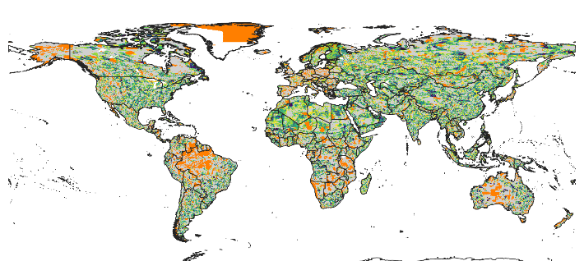

Figure 3: Spider plot biomes vs scenarios. % values are in relation to base value results. Could also do how much of each biome was selected, but that’s not very informative (see small figure below). I’m also not convinced that those spider plots are easy to read, might be better with x = biome, y = value and colors = scenarios plot.

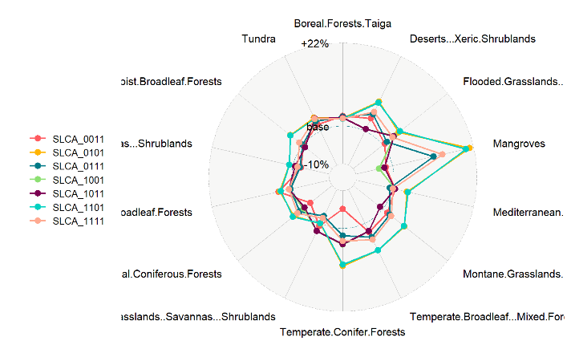

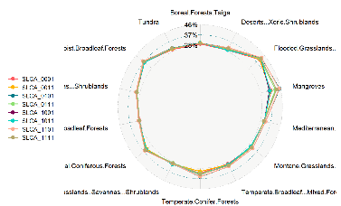

**Methods**

*Species selection*

Our species lists were determined using the IUCN Red List of threatened species, following Pouzols et al. (2014). For mammal, amphibian and reptile species ranges, we used the IUCN Red List website (<http://www.iucnredlist.org/>, accessed 2019-11-14) and for birds we used the BirdLife International data zone webpage (<http://www.birdlife.org/datazone/home>, accessed 2019-11-14). We used these taxa because analogous data are available for a low proportion of species in other taxonomic groups. These data have certain limitations, including possible underestimation of the extent of occurrence and overestimation of the true area of occupancy 7, but have been shown to be robust to commission errors as long as the focus is on species assemblages rather than single species, 8. They are currently the most frequently used and updated source for vertebrate species distributions 9.

For each taxonomic group, we restricted our analysis to species that fell into the presence category of ‘Extant’, the origin categories of ‘Native’ or ‘Reintroduced’ and the seasonality categories ‘Resident’, ‘Breeding Season’ or ‘Non-breeding Season’, thus only focusing on stationary periods of the life cycle of migratory species. This resulted in the following final numbers of amphibian, bird, mammal and reptile species ranges: 5660, 13375, 5442, 6153.

*Basic administrative delineations*

National boundaries were derived from the Global Administrative Areas database (<http://gadm.org/>, accessed 2019-10-31).

We obtained protected area boundaries from the World Database on Protected Areas (WDPA, [https://www.protectedplanet.net](https://www.protectedplanet.net/)). Following standard procedures for cleaning the protected area dataset, we (i) reprojected the data to an equal-area coordinate (World Behrman) (ii) excluded reserves with unknown or proposed designations, (iii) excluded UNESCO Biosphere Reserves 10, (iv) buffered sites represented as point localities to their reported area, (v) dissolved boundaries to prevent issues with overlapping areas, and (vi) removed slivers (code available at https://github.com/jeffreyhanson/global-protected-areas). After the protected area data, we overalaid the protected area boundries with a 10 x 10 km grid covering the Earth. These spatial data procedures were completed using ArcMap (version 10.3.1) and python (version 2.7.8).

*Socioeconomic uncertainty*

11

<https://datacatalog.worldbank.org/dataset/worldwide-governance-indicators>

Mean World Bank Index per country.

*Land use change uncertainty*

We used a global land systems map for the year 2000 (Eitelberg et al., 2016; van Asselen and Verburg, 2012) and a global land systems change model (CLUMondo) (van Asselen and Verburg, 2013) to examine land-use change across the globle. Spatially explicit land-use change models are important tools to analyze potential land-use trajectories for ecological analysis (e.g. Jetz et al., 2007; LaSorte et al., 2017) and provide information to evaluate policy options. The CLUMondo model simulates land-use change at an approximately 9.3 x 9.3 km spatial resolution based on regional demands for goods and resources dependent on factors that promote or constrain land conversion. The modelling approach goes beyond other global land-use models by distinguishing land systems that combine land cover with indicators of land use. This way we are able to distinguish more realistically the mosaics of land use that are relevant to biodiversity. Changes in land-use are simulated using empirically quantified relations between land systems, biophysical location and socio-economic factors, in combination with dynamic modeling of competition between different land systems. Model outputs are based on a land systems classification representing combinations of land cover, land use intensity and livestock presence.

We used the CLUMondo model to simulate land system change for three shared socioeconomic pathway (SSP) scenarios, which allow us to compare the predicted change in land cover between 2000 and 2050 for each scenario. In implementing the three SSP scenarios, model settings are according to the SSP narratives (O’Neill et al., 2014) while demand for agricultural commodities and livestock are derived from assessments with the integrated assessment model IMAGE ([Stehfest et al., 201](https://www-sciencedirect-com.vu-nl.idm.oclc.org/science/article/pii/S0959378017311718#bib0265)4) at the level of world regions. Climate change is taken into account by incorporating change in temperature and precipitation drivers and in suitability for cropland conversion. Data used to determine the influence of climate change in CLUMondo was obtained from the Worldclim database (Hijmans et al. 2005) and the FAO’s database on Global Agro-Ecological Zones (IIASA/FAO 2012). Climate change radiative forcing is projected to be approximately 6W/m2 by 2100 for the three SSPs, which, by 2050 is equivalent to the RCP 4.5 and RCP 6 scenarios, or the SRES B1 scenario (IPCC 2014).

The Sustainability Scenario (SSP1) and the Regional Nationalism scenario (SSP3) represent contrasting low and high challenges to mitigation and adaptation, respectively (Riahi et al., 2017). In SSP1, development strategies shift globally towards sustainability. Investments in education and health accelerate the demographic transition amid economic growth that focuses more broadly on improving human well-being and reducing inequality among and within countries. Consumption is directed towards low material growth and lower resource and energy intensity. In SSP3, countries experience heightened nationalism, competitiveness and security concerns and regional conflicts that drive a policy agenda oriented toward domestic and regional security issues. Countries focus on achieving energy and food security goals within their own regions at the expense of broader-based development. Population growth is high in developing countries and low in industrialized countries. Environmental concerns remain a low international priority, resulting in strong environmental degradation in some regions. The intermediate scenario (Business-as-Usual, SSP2) captures moderate challenges to mitigation and adaptation, with historically consistent trends in technological, economic and societal progress. Population growth continues to rise over the next few decades before leveling off mid-century.

Each of the 23 land use classes was assigned a threat score, based on the following table. The final threat score was comprised of crop, livestock and urban components, which were added to yield a final threat score.

|  |  |  |  |  |  |
| --- | --- | --- | --- | --- | --- |
| No | Description | threat_score | crop_part | livestock_part | urban_part |
| 0 | Cropland; extensive with few livestock | 1 | 0.75 | 0.25 | 0 |
| 1 | Cropland; extensive with bovines, goats & sheep | 1 | 0.75 | 0.5 | 0 |
| 2 | Cropland; medium intensive with few livestock | 0.75 | 0.5 | 0.25 | 0 |
| 3 | Cropland; medium intensive with bovines, goats & sheep | 1 | 0.5 | 0.5 | 0 |
| 4 | Cropland; intensive with few livestock | 0.5 | 0.25 | 0.25 | 0 |
| 5 | Cropland; intensive with bovines, goats & sheep | 0.75 | 0.25 | 0.5 | 0 |
| 6 | Mosaic cropland and grassland with bovines, goats & sheep | 0.75 | 0.25 | 0.5 | 0 |
| 7 | Mosaic cropland (extensive) and grassland with few livestock | 1 | 0.75 | 0.25 | 0 |
| 8 | Mosaic cropland (medium intensive) and grassland with few livestock | 0.75 | 0.5 | 0.25 | 0 |
| 9 | Mosaic cropland (intensive) and grassland with few livestock | 0.5 | 0.25 | 0.25 | 0 |
| 10 | Mosaic cropland (extensive) and forest with few livestock | 1 | 0.75 | 0.25 | 0 |
| 11 | Mosaic cropland (medium intensive) and forest with few livestock | 0.75 | 0.5 | 0.25 | 0 |
| 12 | Mosaic cropland (intensive) and forest with few livestock | 0.5 | 0.25 | 0.25 | 0 |
| 13 | Dense forest | 0 | 0 | 0 | 0 |
| 14 | Open forest with few livestock | 0.25 | 0 | 0.25 | 0 |
| 15 | Mosaic grassland and forest | 0 | 0 | 0 | 0 |
| 16 | Mosaic grassland and bare | 0 | 0 | 0 | 0 |
| 17 | Natural grassland | 0 | 0 | 0 | 0 |
| 18 | Grassland with few livestock | 0.25 | 0 | 0.25 | 0 |
| 19 | Grassland with bovines, goats and sheep | 0.5 | 0 | 0.5 | 0 |
| 20 | Bare | 0 | 0 | 0 | 0 |
| 21 | Bare with few livestock | 0.25 | 0 | 0.25 | 0 |
| 22 | Peri-urban & villages | 0.75 | 0 | 0 | 0.75 |
| 23 | Urban | 1 | 0 | 0 | 1 |

To incorporate the temporal component of the SSP scenarios, we created a threat score change metric that was a combination of current (1/3 weight) and future predictions (2/3 weight). Example calculations can be found in the following example table. We created one predictive surface for each of the three SSP scenarios. In the main analysis we focus on the SSP 2 scenario (middle of the road).

|  |  |  |
| --- | --- | --- |
| current | future | **1*a + 2*b/3** |
| 0 | 0 | **0** |
| 0.25 | 0.25 | **0.25** |
| 0.5 | 0.5 | **0.5** |
| 0.75 | 0.75 | **0.75** |
| 1 | 1 | **1** |
| 0 | 0.25 | **0.17** |
| 0.25 | 0.5 | **0.42** |
| 0.5 | 0.75 | **0.67** |
| 0.75 | 1 | **0.92** |
| 1 | 1 | **1** |
| 0 | 0 | **0** |
| 0.25 | 0 | **0.08** |
| 0.5 | 0.25 | **0.33** |
| 0.75 | 0.5 | **0.58** |
| 1 | 0.75 | **0.83** |
| 0 | 0 | **0** |
| 0.25 | 0 | **0.08** |
| 0.5 | 0 | **0.17** |
| 0.75 | 0 | **0.25** |
| 1 | 0 | **0.33** |
| 0 | 1 | **0.67** |
| 0.25 | 1 | **0.75** |
| 0.5 | 1 | **0.83** |
| 0.75 | 1 | **0.92** |
| 1 | 1 | **1** |

*Climate uncertainty*

For initial test purposes we have used climate change velocity from 12as the climate risk component in the multi-objective optimization formulation. We will also explore climate novelty and extreme metrics from Frank La Sorte.

*Multi-objective optimization of risk reduction*

We processed all data described before to a 10 x 10 km resolution and clipped data to the extent of land based on the global administrative areas database.

Here, we developed an extension on the minimum set problem, which has the goal to identify a set of sites within a planning area that represents all conservation targets in the fewest number of sites 13. Instead of including one objective we are expanding the formulation to include multiple objectives in the problem formulation. We use a hierarchical or lexicographic approach that assigns a priority to each objective, and optimizes for the objectives in decreasing priority order. At each step, it finds the best solution for the current objective, but only from among those that would not degrade the solution quality for higher-priority objectives. We considered up to three objectives in our prioritization scenarios, i) socioeconomic risk, ii) land use change risk, and iii) climate risk. To compare different risk scenarios we calculated solutions for each unique objective combination (n = 7), as well as one where we use a constant objective function as the base scenario.

For all scenarios we locked in current protected areas and used the same feature set of 30930 vertebrates. The target for each feature was set to 30% of their range. The optimality gap we use was 5% for each objective in the hierarchy. We started the hierarchy with socioeconomic risk, followed by land use change risk and climate risk to reflect the immediacy of each risk on current biodiversity (socioeconomic best predictor for success currently; land use higher current impact than climate). Sensitivity analysis showed that reversing the priority order did not influence our results (supp mat).

**Methods references**

**Acknowledgements**

**Author contributions**

**Competing interest declaration**

**Parking lot**

and current patterns of land use.

**Figure S1. Socio-economic (green = good, red = bad)**

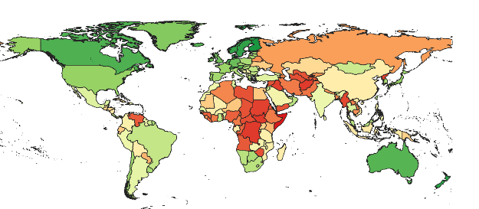

**Figure S2. Land use change (green = good, red = bad)**

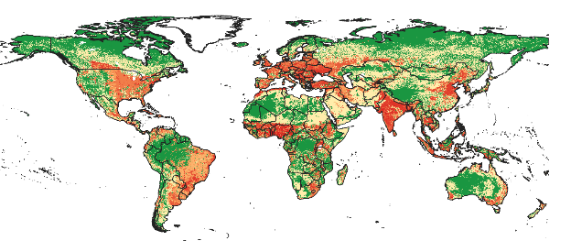

**Figure S3. Climate (extreme heat events) (green = good, red = bad)**

